Assignment-Chapter 7&8 (100 points)

Student Name: Jayadeep Reddy Karri ID:664646469

1. Please write down two ways to set the range of an axis in a plot. (4 points)

xlim() and ylim() to set the minimum and maximum values of a continuous axis.

ylim() is shortcut for setting the limits with scale_y_continuous() **.**

The following does the same thing:

ylim (0, 90)

scale_y_continuous (limits=c (0, 90))

The same is true for xlim() and scale_x_continuous() **.**

The following does the same thing:

xlim (0, 20)

scale_x_continuous (limits=c (0, 20))

1. Use the mtcars data frame to to draw four graphs, respectively. Write down the used functions in ggplot2 (30 points)

(a) ggplot(mtcars, aes(x=wt, y=mpg)) + geom_point()+ annotate("text",x=4,y=25,label="Some text")

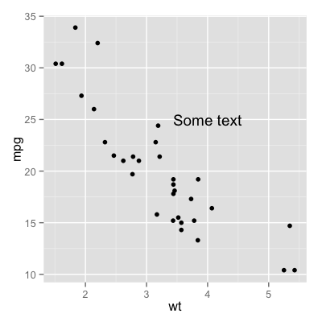

(b) ggplot (mtcars, aes(x = wt, y = mpg)) + geom_point() + annotate ( "text", x = 2.5, y = 25, label = "Some text")

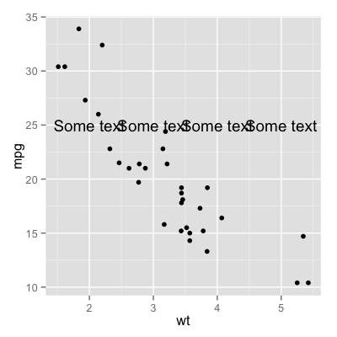

(c) ggplot(mtcars, aes(x = wt, y = mpg)) + geom_point() + annotate("rect", xmin = 3, xmax = 4.2, ymin = 12, ymax = 22,alpha=.2)

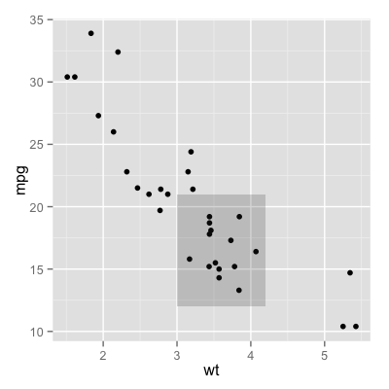

(d) ggplot(mtcars, aes(x = wt, y = mpg)) + geom_point() + annotate("segment", x = 2.4, xend = 4, y = 15, yend = 25,color="blue")

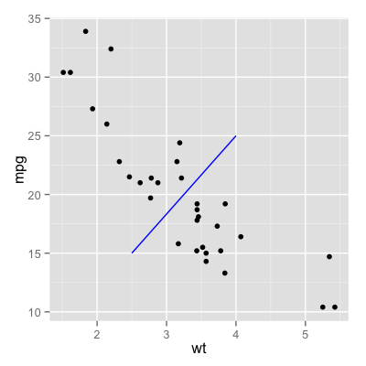

(e) ggplot(mtcars, aes(x = wt, y = mpg)) + geom_point() + annotate("text", x = 2:3, y = 20:21, label = c("my label", "label 2"))

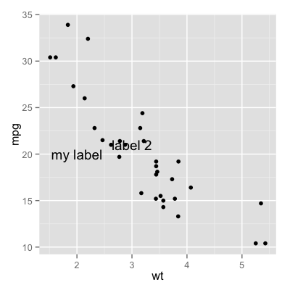

1. Use data frame PlantGrowth and write functions to draw graphs, respectively. (30 points)

(a) library(ggplot2)

ggplot(PlantGrowth, aes (x=group, y=weight)) + geom_boxplot()

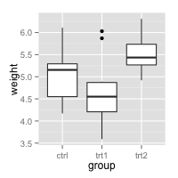

(b) ggplot( PlantGrowth, aes (x=group, y=weight)) + geom_boxplot() + coord_flip()

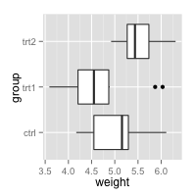

(c) ggplot( PlantGrowth, aes (x=group, y=weight)) + geom_boxplot() + scale_x_discrete ( limits = c("trt1","trt2","ctrl"))

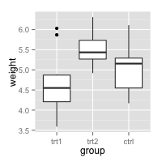

(d) ggplot( PlantGrowth, aes (x=group, y=weight)) + geom_boxplot() + scale_x_discrete(limits=c("trt1","trt2","ctrl"))+ scale_x_discrete ( limits = rev (levels (PlantGrowth$group)))

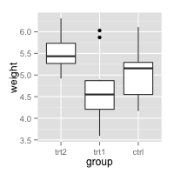

1. Following the same data frame in question 2, and use and write functions to draw the following graphs, respectively. (18 points)
2. ggplot( PlantGrowth, aes (x=group, y=weight)) + geom_boxplot() + scale_x_discrete ( breaks=c("ctrl", "trt1", "trt2"), labels = c ("Control", "Treat 1", "Treat 2"))

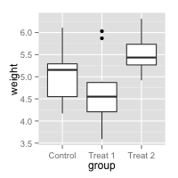

(b) ggplot( PlantGrowth, aes (x=group, y=weight)) + geom_boxplot() + scale_x_discrete ( breaks = NULL)

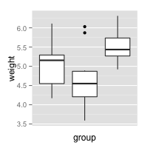

(c) ggplot( PlantGrowth, aes (x=group, y=weight)) + geom_boxplot() + theme ( axis.ticks = element_blank(), axis.text.x = element_blank())

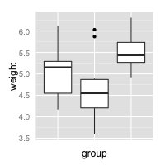

1. Following the same data frame in question 2, and use and write functions to draw the following graphs, respectively. (18 points)

(a) ggplot( PlantGrowth, aes (x=group, y=weight)) + geom_boxplot() + theme ( axis.title.x = element_blank()) + ylab("Weight (Kg)")

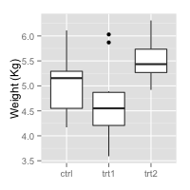

1. ggplot( PlantGrowth, aes (x=group, y=weight)) + geom_boxplot() + scale_x_discrete ( name="" ) + scale_y_continuous ( name="Weight (Kg)")

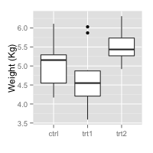

(c) You can use any size and color for the text.

ggplot( PlantGrowth, aes (x=group, y=weight)) + geom_boxplot() + theme ( axis.title.x = element_text (face="bold", color = "#990000", size=20), axis.text.x = element_text (angle=90, vjust=0.5, size=16))

